Team 10

Team Presentation 2

Keys to Becoming a Billionaire

Sofia Huang, Elias Hairaditis, Samariddin Zarifov

# Introduction:

Our journey into exploring the intriguing world of billionaires began with the discovery of the Billionaires Statistics Dataset (2023) on Kaggle, compiled by Nidula Elgiriyewithana. Intrigued by the desire to unravel trends and patterns among this elite group, our team formulated essential business questions. This exploration led us to a deeper investigation into the wealth disparities between self-made and inherited billionaires, prompting us to delve into the question of what distinct patterns most billionaires possess.

In our pursuit to inspire and inform our audience about the pathways to success, we aim to emphasize the distribution of billionaires, highlight their diverse backgrounds, and underscore the importance of being a self-starter. Tailoring our approach to resemble a "TED" talk rather than a conventional business meeting, we cater to potential entrepreneurs seeking inspiration.

# Description of Data:

Before delving into the creation of models, our team analyzed the Billionaires Statistics Dataset. Crucial variables such as rank, final net worth, age, country of residence, industries, business category, and country of citizenship provided a comprehensive understanding of the billionaire landscape. In comparing these variables, patterns began to emerge. Noteworthy conclusions include the observation that most billionaires fall within the age range of their mid-50s to 60s, with a significant concentration of billionaires in the technology sector in the United States, especially in New York and California. Furthermore, a compelling trend unfolded as different countries exhibited varying percentages of billionaires in distinct industries, exemplified by the prevalence of tech billionaires in the USA and fashion moguls in France. Moreover, the data revealed that over 70% of billionaires are self-made, reinforcing the significance of individual initiative in attaining billionaire status.

# Our Dashboards:

In the creation of our comprehensive dashboards, analysis of the data guided our focus on selecting appropriate graphical representations. For our first dashboard, "Industries by Country," we employed a bar graph to visually highlight the industries with the highest billionaire counts. Complementing this, a world map visualization demonstrated the global distribution of billionaires, underscoring the USA's dominance in this elite group. To provide insight into industry leaders, we incorporated another bar graph showcasing the top 5 individuals in each selected sector, allowing the audience to explore the leaders' final wealth. Additionally, a bar graph illustrating the billionaires to population ratio helped the audience grasp the rarity of billionaire status.

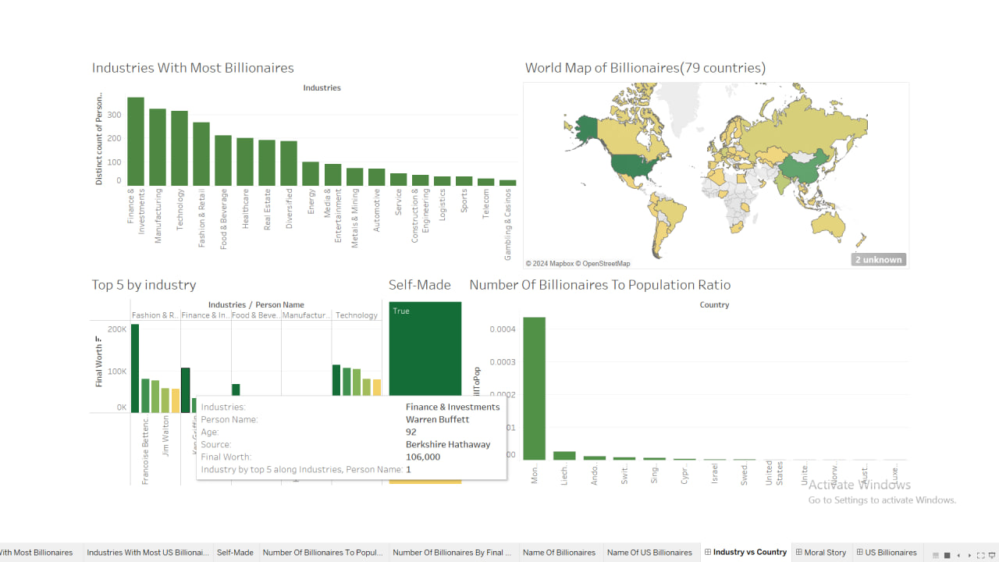

Our second dashboard, aptly named "Moral Story," aimed to illuminate the path to billionaire status. It focuses with a dynamically controlled list displaying billionaire names and final worth. This list seamlessly interacted with a stacked bar plot depicting the percentage of self-made billionaires, emphasizing the pivotal role of individual initiative versus inherited wealth. An age distribution bar plot further enriched the narrative, illustrating the diverse ages among billionaires. Furthermore, a connected bar plot demonstrated the gender gap in relation to the industries in which billionaires operate, while the last graph illustrates the distribution of billionaires by distinct final worth and billionaires whose final worth are over $20 billion are easily countable. The main moral story is that self-made billionaires are more than 2 out 3 billionaires and even if self-made billionaires lose their money and power, they have the potential of building all things from scratch, while no one should hurry to be rich and firstly, everyone should be busy with gaining more experience and learning more as most billionaires are over 50 years old.

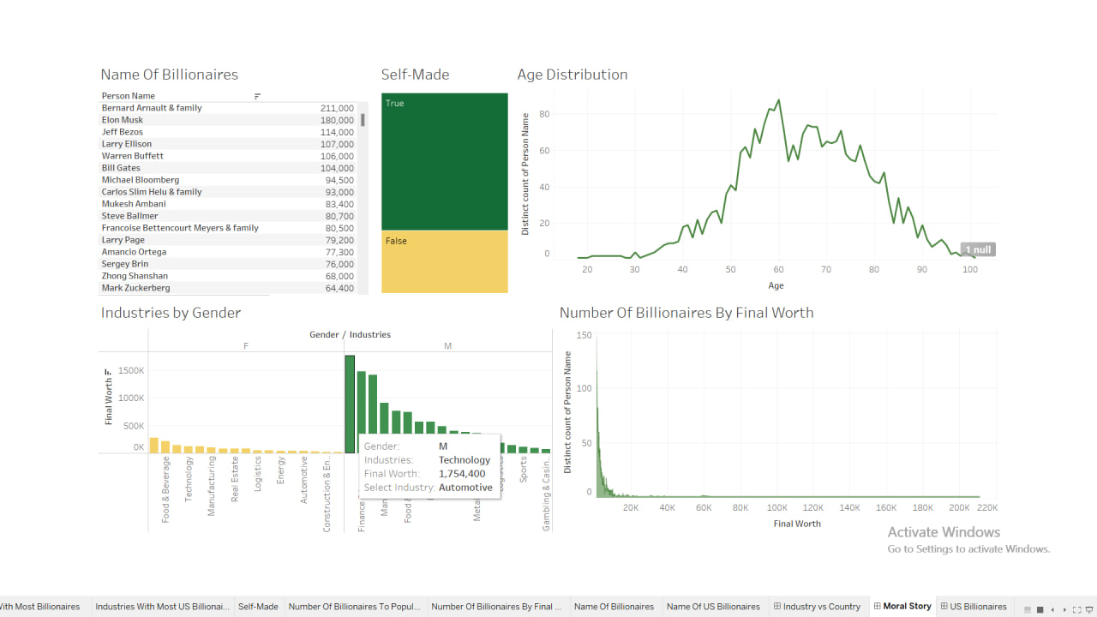

The final dashboard targeted our US-based audience, offering a nuanced perspective on the distribution of billionaires within the country. Serving as a comprehensive tool to influence our audience, it featured a list of billionaire names, a bar graph displaying industries and the count of billionaires in each sector, and a connected map detailing the distribution of billionaires across US states. In alignment with our overarching theme of self-made success, the stacked bar plot underscored the distribution of self-made billionaires, reinforcing the narrative of individual accomplishment in the pursuit of immense wealth.

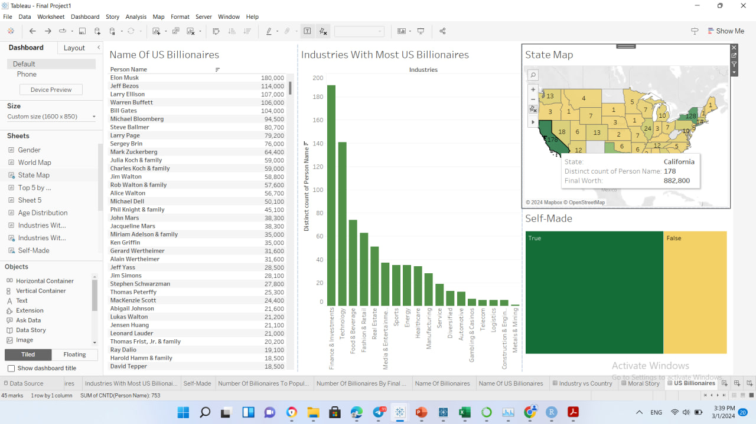

# Moral of our Findings:

Engaging in the creation of these dashboards was a gratifying experience, enabling us to visually uncover intricate patterns that would have been challenging to discern otherwise. Through our presentation, we aspired to empower the audience to take proactive steps in shaping their unique paths to success. The visualization of data proved instrumental in conveying our message, emphasizing the significance of self-initiative and diverse strategies in the pursuit of success. Given more time, our team harbored a desire to delve even deeper, exploring additional datasets with yearly data. This expansion would have facilitated the projection of trends into the future through stochastic modeling, providing individuals with insights into the pace at which individuals are achieving billionaire status.

# Conclusion:

Crafting this presentation was a thoroughly enjoyable process, and our efforts culminated in the successful resolution of our thesis through insightful analysis. The dashboards served as powerful tools for conveying our message, illustrating the diverse pathways to billionaire success and underscoring the importance of self-made achievements. As we conclude this project, we reflect on the valuable lessons learned and the potential impact our findings may have on inspiring others to embark on their journeys toward success.